Macroplastics by source

2023-01-07

library(tidyverse)

## ── Attaching packages ─────────────────────────────────────── tidyverse 1.3.2 ──  
## ✔ ggplot2 3.4.0 ✔ purrr 1.0.0   
## ✔ tibble 3.1.8 ✔ dplyr 1.0.10  
## ✔ tidyr 1.2.1 ✔ stringr 1.5.0   
## ✔ readr 2.1.3 ✔ forcats 0.5.2   
## ── Conflicts ────────────────────────────────────────── tidyverse_conflicts() ──  
## ✖ dplyr::filter() masks stats::filter()  
## ✖ dplyr::lag() masks stats::lag()

library(readxl)  
library(plotrix)  
macroplastics <- read_excel("~/Desktop/MB5001 Macroplastics Data.xlsx")

macroplastics %>%   
 ggplot() +  
 geom_bar(mapping = aes(fill = category, x = Tidal_line), na.rm = T) +  
 ggtitle("Source of debris separated by tidal zone (abundance)")

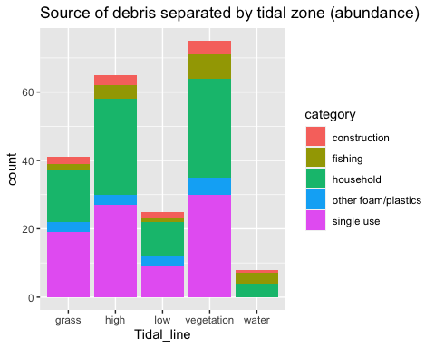

macroplastics %>%   
 ggplot() +  
 geom_bar(mapping = aes(fill = category, x = Tidal_line), na.rm = T, position = "fill") +  
 ggtitle("Source of debris (percentage) separated by tidal zone")

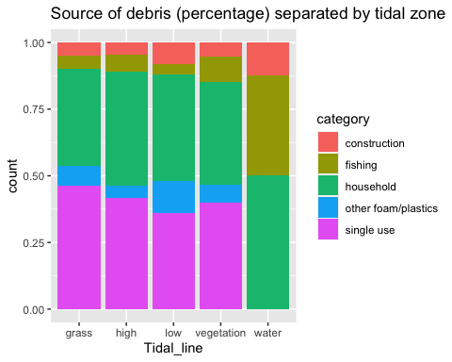

macroplastics %>%   
 ggplot() +  
 geom_bar(mapping = aes(fill = category, x = Site), na.rm = T) +  
 ggtitle("Source of debris separated by site (abundance)")

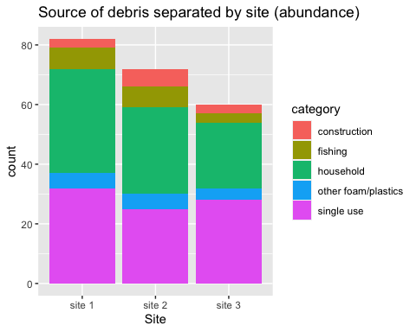

macroplastics %>%   
 ggplot() +  
 geom_bar(mapping = aes(fill = category, x = Site), na.rm = T, position = "fill") +  
 ggtitle("Source of debris (percentage) separated by site")

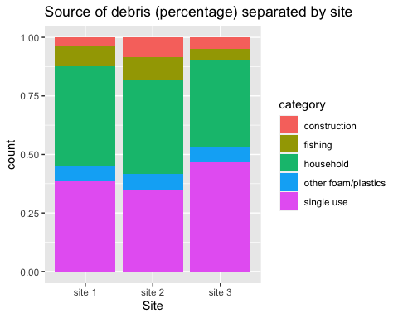

macroplastics %>%   
 ggplot() +  
 geom_bar(mapping = aes(fill = category, x = Tidal_line), na.rm = T, position = "fill") +  
 ggtitle("Source of debris (percentage) separated by tidal zone") +  
 facet_wrap(~ Site)

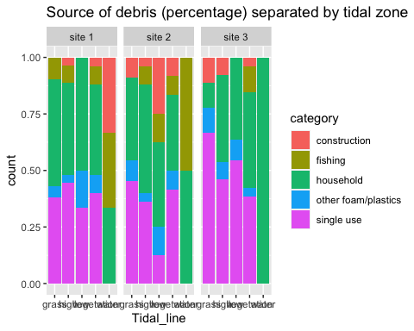

For average count for each source with standard error bars:

category_summary <- macroplastics %>%   
 group_by(category) %>%   
 summarise(mean = mean(Count), std_error = std.error(Count))  
  
ggplot(category_summary, aes(x = category, y = mean)) +  
 geom_bar(stat = "identity") +  
 geom_errorbar(aes(ymin = mean - std_error, ymax = mean + std_error), width = 0.4, size = 0.4) +  
 labs(x = "Source/category", y = "Mean rubbish count (+/- SE)")

## Warning: Using `size` aesthetic for lines was deprecated in ggplot2 3.4.0.  
## ℹ Please use `linewidth` instead.

